What is Dyslexia?
Short Answer:
Dyslexia is an inherited condition that makes it extremely hard to read, write, and spell—despite having at least average intelligence.

Long answer:
Dyslexia is a neurologically-based disorder (that often runs in families) which interferes with the ability to acquire and understand language. Although it shows up in different levels of severity, people who are dyslexic have a hard time with “receptive and expressive language”, which includes reading, writing, spelling, handwriting, and sometimes also math.
Dyslexia does not happen because of not being motivated, having a sensory problem, or not having the same environmental opportunities. However, many times dyslexia occurs together with these conditions.
Although dyslexia affects people for their whole lives, dyslexic people often have good success with interventions when they are done in a timely and appropriate manner.

What causes dyslexia???
Dyslexia is an inherited condition. Researchers have determined that a specific gene or set of genes is responsible for dyslexia. That gene is dominant, so it is very easy for it to be passed from a parent to their children. It definitely runs in families.
Dyslexia comes from a neurological difference; that is, a difference in the brain. Some scientific studies say that the right side of the brain in dyslexic people is different, and that may be why people with dyslexia often are very good at some activities, like being artistic, athletic, and mechanically gifted. Also, they tend to be different with musical talent, creative problem solving skills, and intuitive people skills.
In addition to this, people with dyslexia have unusual "wiring". Neurons are found in unusual places in the brain, and are not as neatly ordered as in non-dyslexic brains. Also, some studies have shown that people with dyslexia do not use the same part of their brain when reading as other people. Regular readers consistently use the same part of their brain when they read. People with dyslexia do not use that part of their brain, and there appears to be no consistent part used among dyslexic readers.
It is therefore assumed that people with dyslexia are not using the most efficient part of their brain when they read. A different part of their brain has taken over that function.

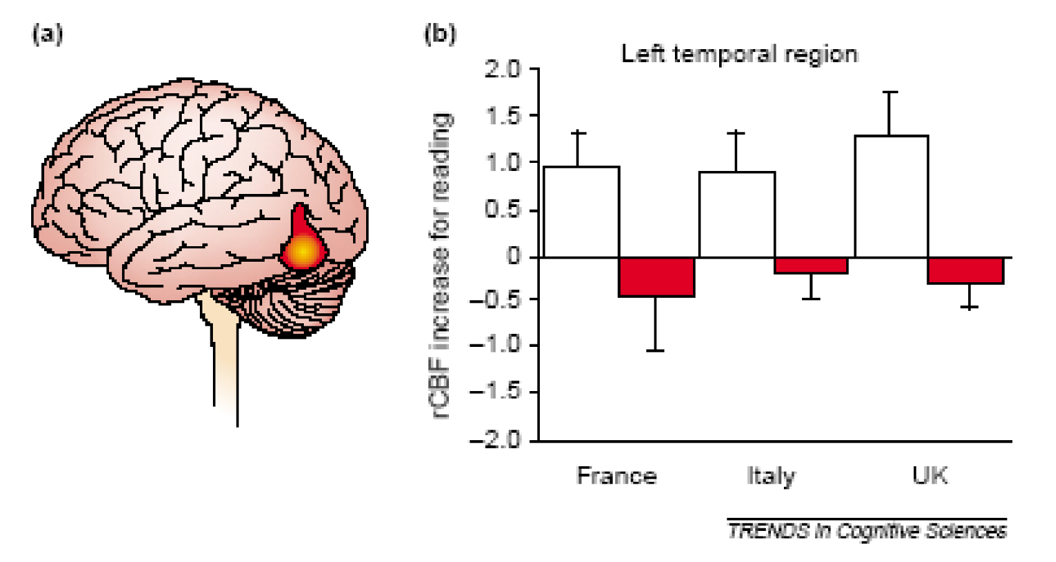

(a) - Normal readers show more activity in the “visual word form area” in the brain than people who are dyslexic.
(b) – In general, this same trend is seen in normal readers (white bars) and dyslexic individuals, regardless of whether they are reading French, Italian, or English.

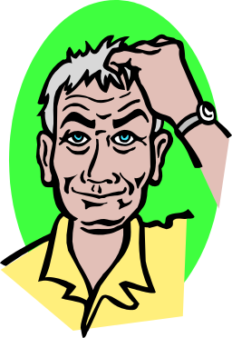
What Dyslexia isn’t…
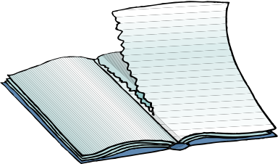
TAC

- Many people think dyslexia means that you read backwards. This is not true! While some dyslexic people do see things a little differently, the truth is that dyslexia just makes it easy to get things confused when trying to read.

- Being dyslexic does not mean you are dumb or a slow learner. In fact, to be “dyslexic”, you have to be just as smart as everybody else - just have a hard time understanding language-based thing like reading and writing.

- Dyslexia does not just go away. Many parents think their child will “grow out of it” or “catch up later”. This is not true. Many dyslexic people simply learn how to work around it, and with proper intervention can learn to read as well as other people.

- Being dyslexic does not mean that you are permanently handicapped, and cannot be a successful person. Many, many famous people are (or were) dyslexic. Some examples include: Jay Leno, Woopi Goldberg, Richard Branson, Walt Disney, Leonardo de Vinci, Thomas Edison, Nelson Rockefeller, and even Albert Einstein.
Many people even believe President George W. Bush is dyslexic but this has not been verified…

